MYSQL ASSIGNMENT 1 DDL COMMANDS AND CONSTRAINTS
Sona Varghese

1. Table Creation (CREATE): Write the SQL statements to create a database named
“employee” and the following tables based on the provided schema:

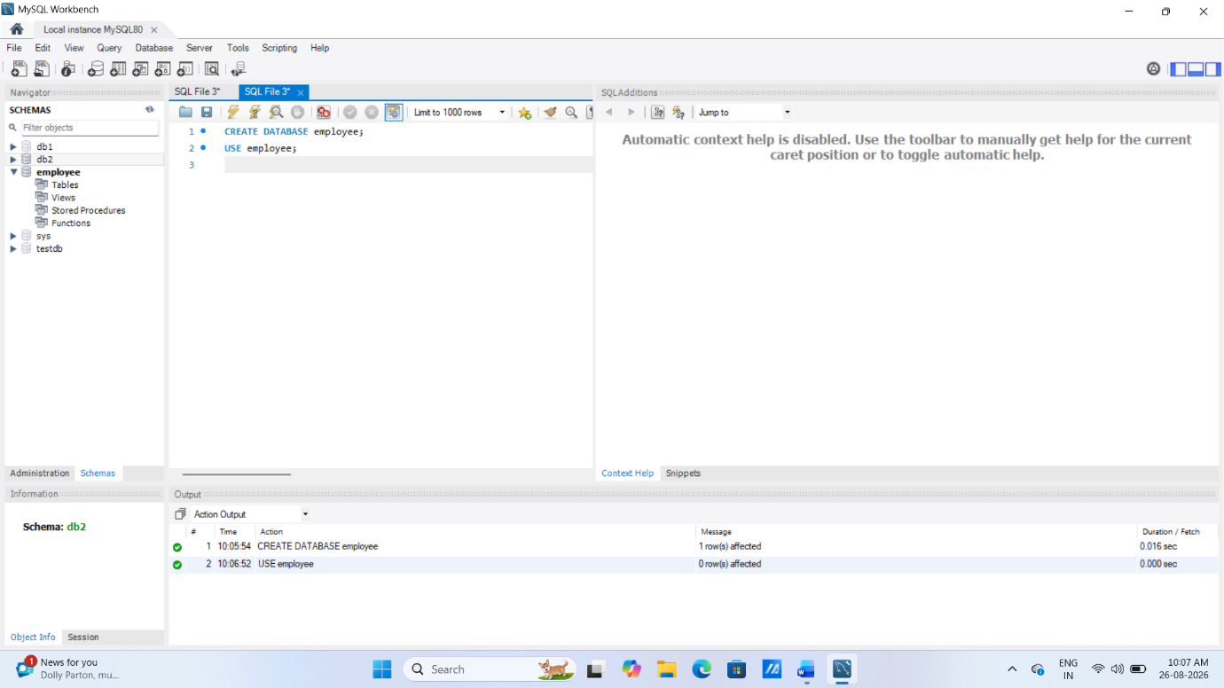
⦿ Departments
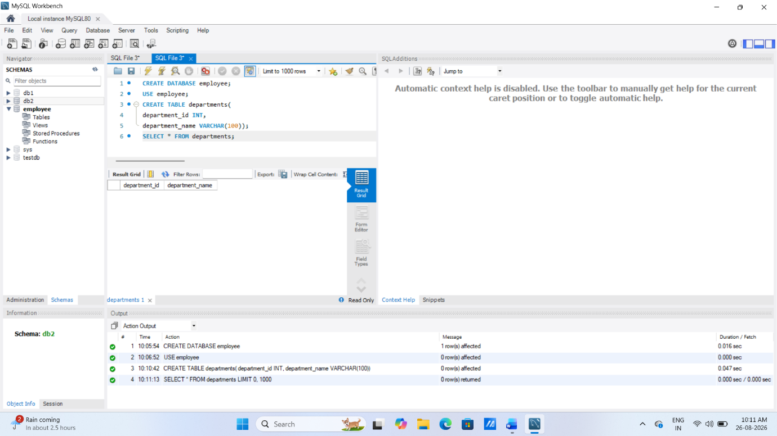
⦿ Location
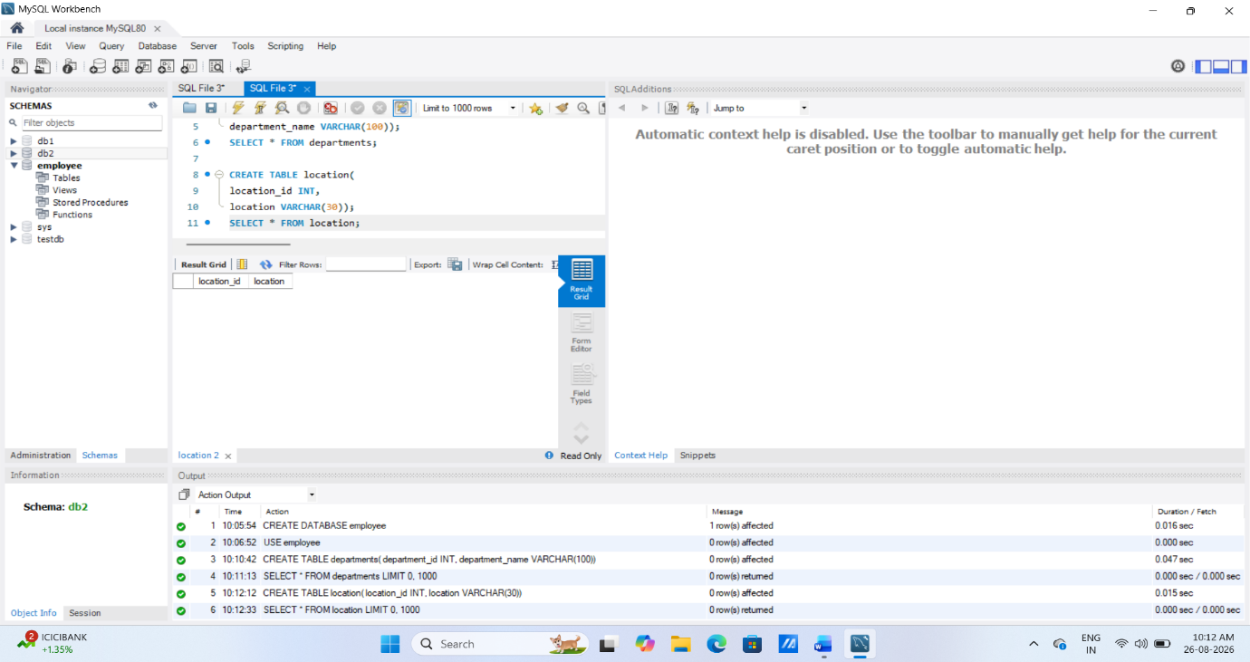
⦿ Employees
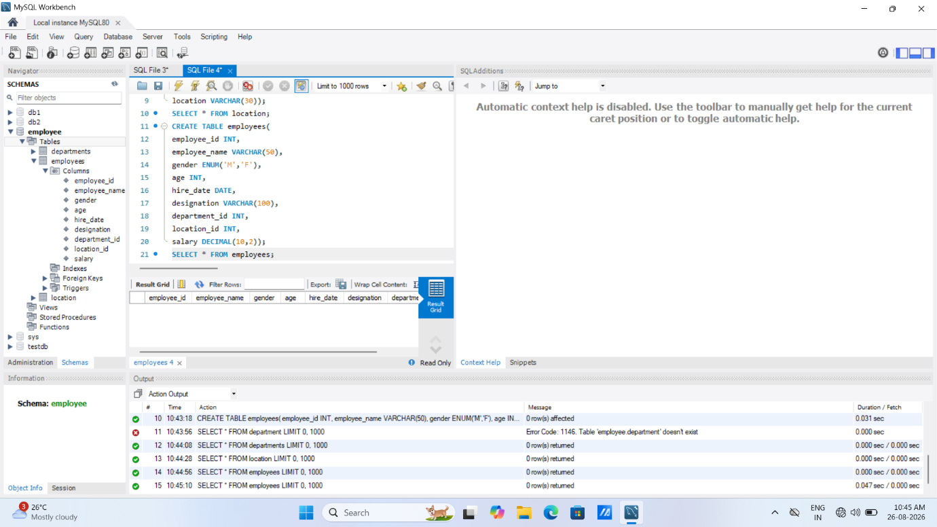
2. Table Alteration (ALTER): Consider the following scenarios and write the SQL
statements to alter the structure of the tables accordingly:
⦿ Add a new column named "email" to the Employees table to store
employee email addresses.
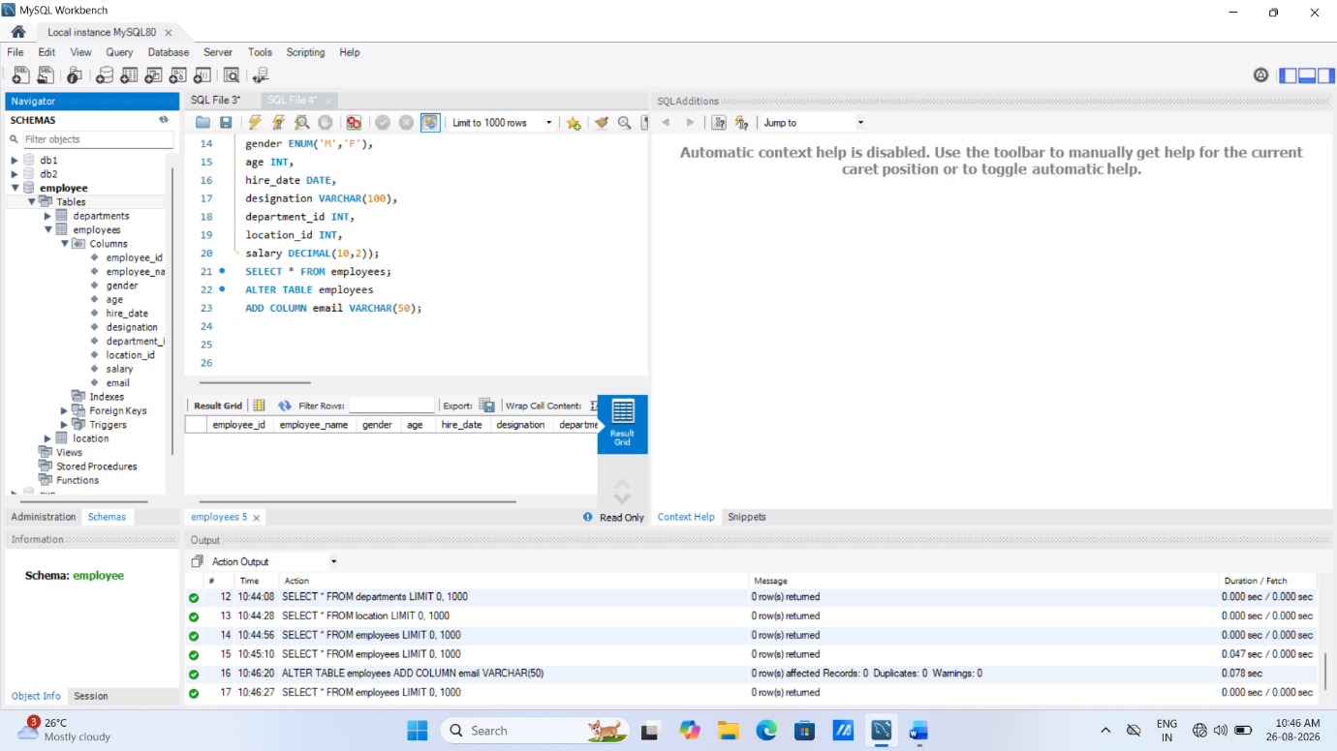
⦿ Modify the data type of the "designation" column in the Employees
table to support a wider range of values.
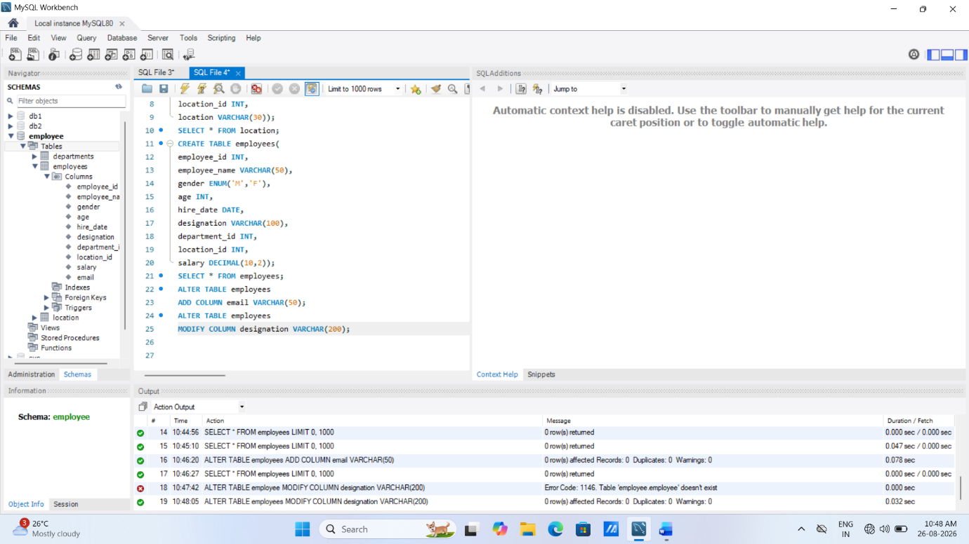

⦿ Drop the “age” column from the Employees table.
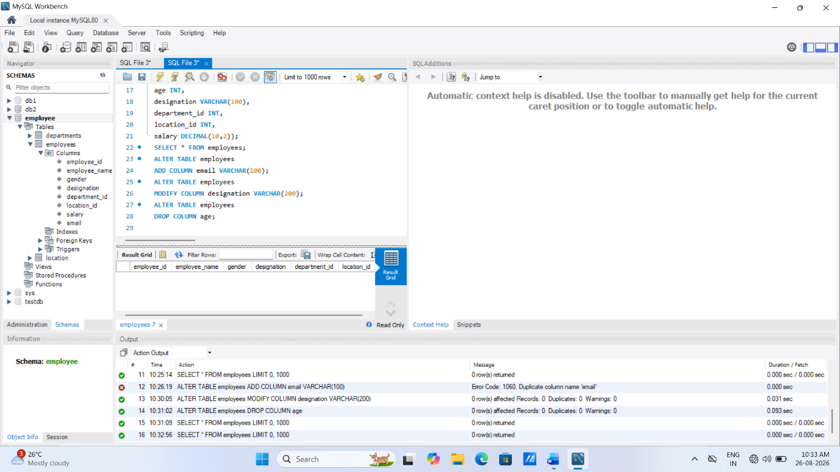
⦿ Rename the “hire_date” column to “date_of_joining”.
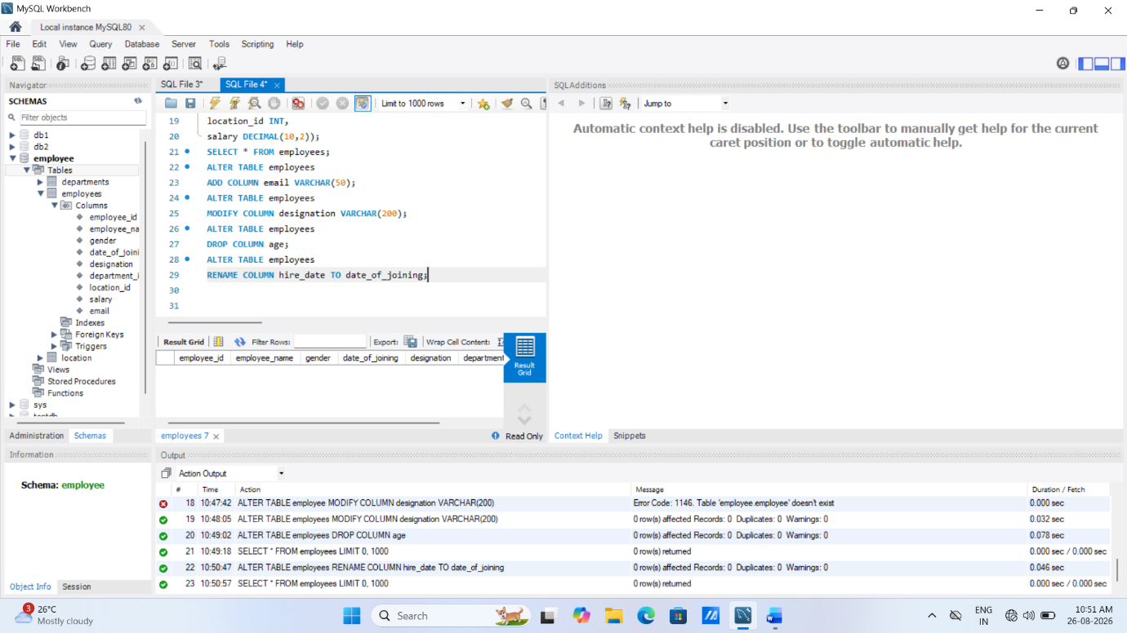

3. Table Renaming (RENAME): Rewrite the SQL statements to rename the
following tables:
⦿ Rename the "Departments" table to "Departments_Info".
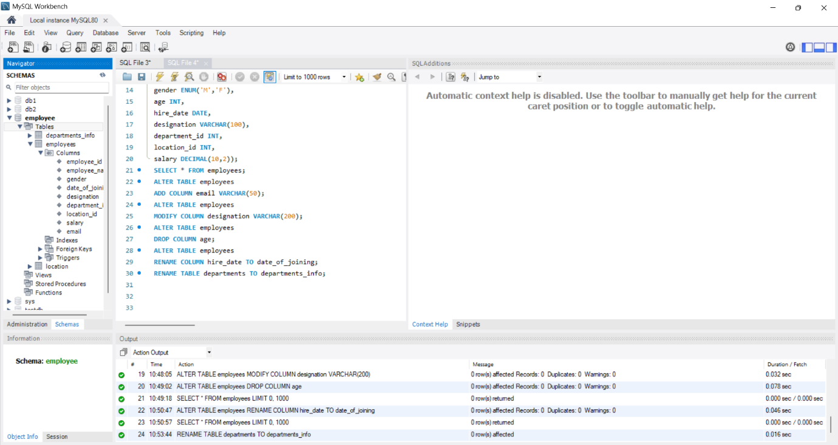
⦿ Rename the "Location" table to "Locations".
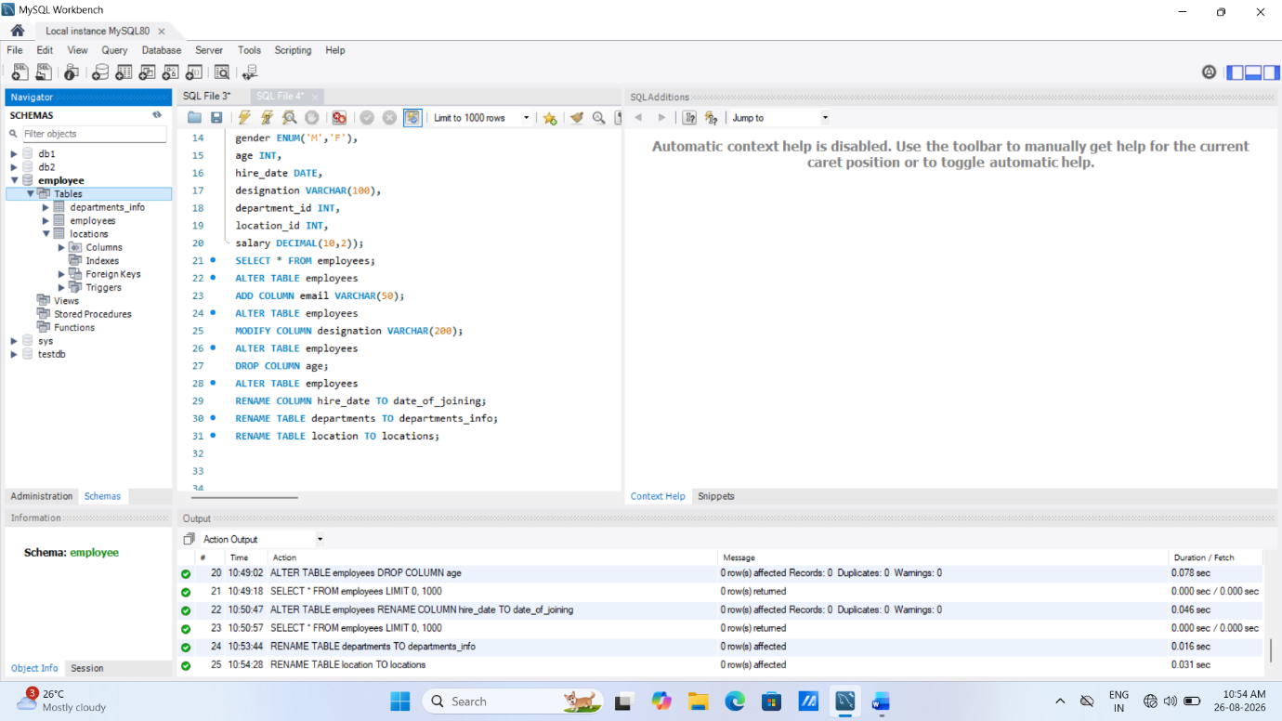

4. Table Truncation (TRUNCATE): Write an SQL statement to truncate the
Employees table.
TRUNCATE TABLE employees;

5. Database & Table Dropping (DROP): Write the SQL statements to drop the
Employees table and then the “employee” database.
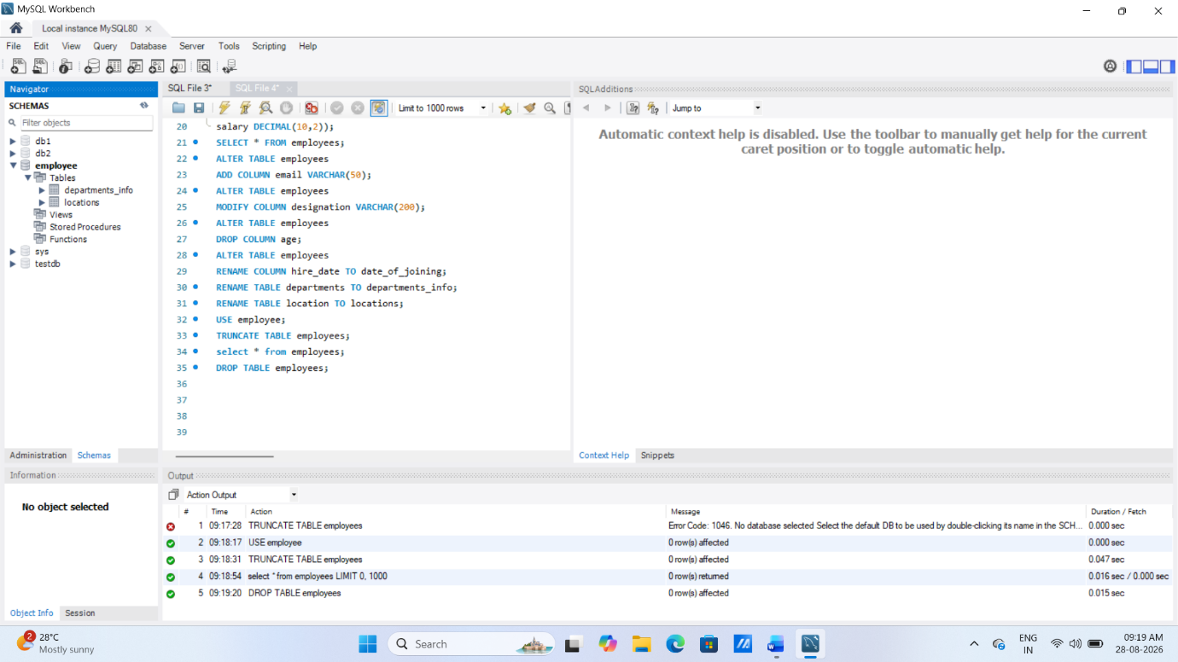
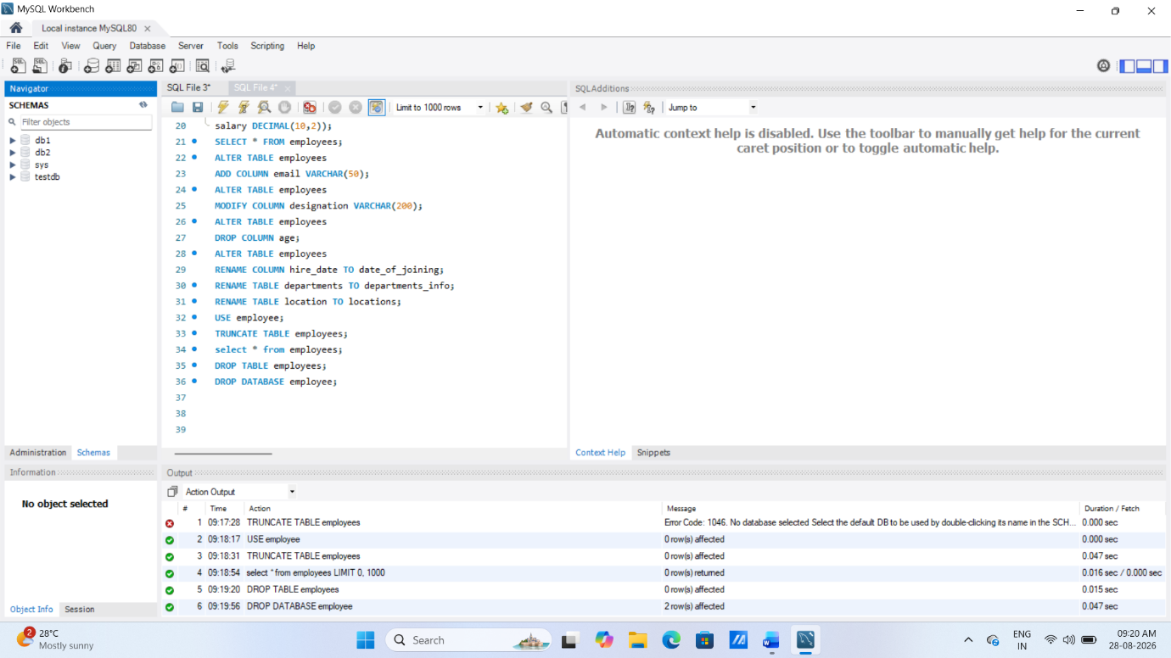
1. Database Recreation:
⦿ Drop the 'employee' database if it exists and recreate it using the
provided schema, ensuring that all tables are created with the
appropriate constraints as instructed.
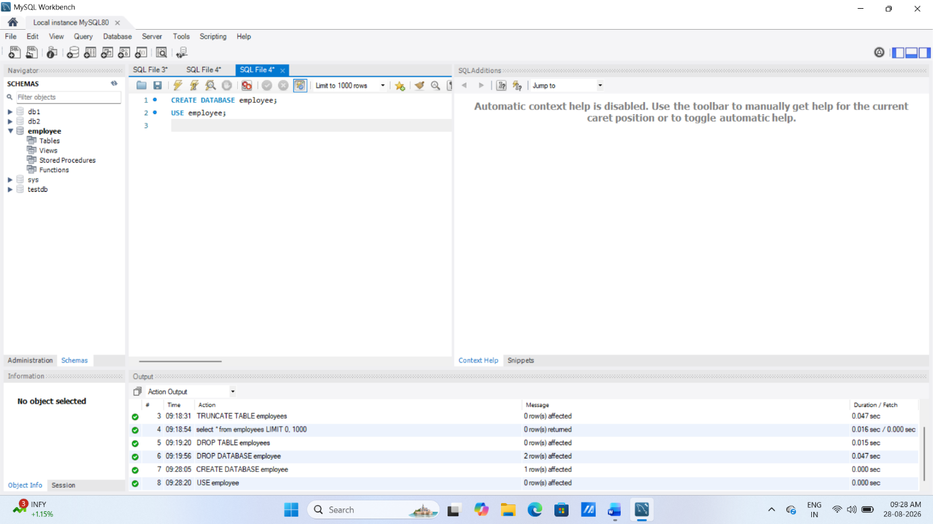

2. Departments Table:
⦿ Ensure that the "department_id" uniquely identifies each department.
‘department_id INT PRIMARY KEY’
⦿ Set up constraints on the "department_name" to avoid duplicate and null entries.
‘department_name VARCHAR(100) NOT NULL UNIQUE’

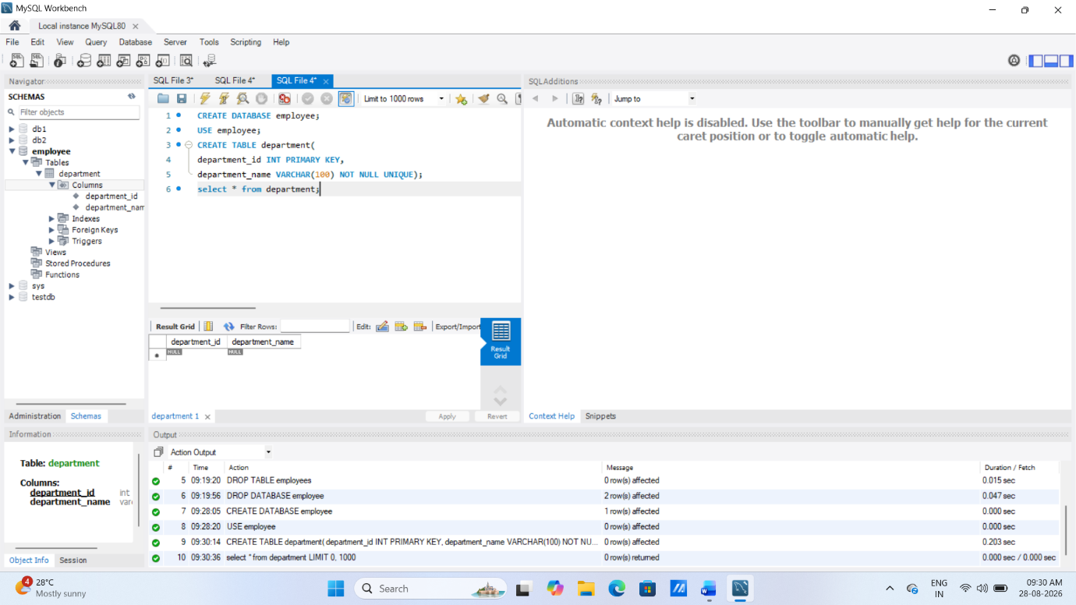
3. Location Table:
⦿ Establish a mechanism to automatically generate unique identifiers for
each location, ensuring that they are incremented sequentially.
‘location_id INT AUTO_INCREMENT PRIMARY KEY’
⦿ Implement constraints to prevent the insertion of null and duplicate
locations.
‘location VARCHAR(30) NOT NULL UNIQUE’
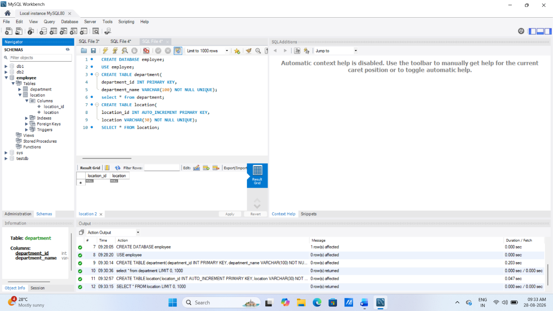
4. Employees Table:
⦿ Guarantee that each employee has a distinct identifier.
‘employee_id INT PRIMARY KEY’
⦿ Create a restriction to ensure that the employee's name is always
provided.
‘employee_name VARCHAR(50) NOT NULL’
⦿ Limit the acceptable values for the "gender" field to only 'M' or 'F'.
‘gender ENUM('M','F')’
⦿ Enforce a condition to ensure that the employee's age is 18 or above.
‘age INT CHECK (age >= 18)’
⦿ Automatically assign the current date to the "hire_date" field if not
specified.
‘hire_date DATE DEFAULT(CURRENT_DATE)’
⦿ Establish links between the "department_id" and "location_id" fields in
the "employees" table and their respective tables.
‘department_id INT,
FOREIGN KEY(department_id) REFERENCES department(department_id),
location_id INT,
FOREIGN KEY(location_id) REFERENCES location(location_id)’
